**Q1) Creating Microservices for account and loan**

**AccountController.java**

package com.cognizant.account.controller;  
  
import org.springframework.web.bind.annotation.*;  
  
import java.util.Map;  
  
@RestController  
@RequestMapping("/accounts")  
public class AccountController {  
  
@GetMapping("/{number}")  
public Map<String, Object>getAccountDetails(@PathVariable String number) {  
  
return Map.*of*(  
"number", number,  
"type", "savings",  
"balance", 234343  
);  
 }  
}

**Output**

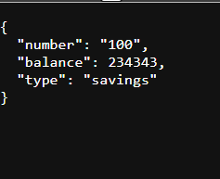

**LoanController.java**

package com.cognizant.loan.controller;  
  
import org.springframework.web.bind.annotation.*;  
  
import java.util.Map;  
  
@RestController  
@RequestMapping("/loans")  
public class LoanController {  
  
@GetMapping("/{number}")  
public Map<String, Object>getLoanDetails(@PathVariable String number) {  
return Map.*of*(  
"number", number,  
"type", "car",  
"loan", 400000,  
"emi", 3258,  
"tenure", 18  
);  
 }  
}

**Output**

